**Structural Requirements (Section 3~)**

Structural requirements for the re-boost mission are derived from the customer mission requirements. Four of the customer requirements specifically relate to the structure. System-level requirements for these customer requirements are shown below:

*Customer Requirements Specific to Structure*

* (b), Rendezvous and dock with HST
  + Docking platform must interface with SCM
  + Determine allowable mating parameters to ensure structural health
* (d), Reboost thrust must result in solar array deflection of no more than 50 cm
  + Solar arrays are oriented for minimal deflection
  + Structural properties for solar arrays are determined
  + Deflection analysis is performed to determine allowable thrust
* (e), Undock from HST and destructively de-orbit in atmosphere
  + Docking platform must reliably un-mate from SCM with redundant mechanical system
* (k), Main body of spacecraft bus must include MMOD shielding
  + See section 3.1

Additional system-level requirements are necessary to ensure the health of the HRV to complete the mission:

*Structural Requirements to Ensure Spacecraft Health*

* Quasi-static loads
  + Spacecraft must meet FOS mechanical stress requirements for maximum expected quasi-static longitudinal and lateral accelerations, as given by launch vehicle provider
* Minimum natural frequency
  + Primary spacecraft structure must have first modes of natural frequency in thrust and lateral directions above the values defined by launch vehicle provider
* Vibration and shock loads (sine wave, random vibration, acoustic, shock)
  + Spacecraft must meet FOS mechanical stress requirements for vibration and shock loads, determined by analyses by launch vehicle provider and HRV team, with respect to expected shock values, notched-level determinations, and predicted power spectral density input

*Size (volume and dimensions) and mass requirements are determined by the following drivers:*

* *Fuel requirements to complete mission (total ΔV)*
* Interface with SCM on HST
* Size of additional hardware necessary for mission (communications, command and control, GNC, power, plumbing)
* Launch vehicle fairing

*Factor of Safety Requirements*

* FOS determined to be XXX to yielding and XXX to ultimate strength for mechanical structures, per XXX

**Spacecraft Structure (Section 13~)**

The structural layout for the HRV is shown below in Figure 1 - Figure 4. The initial driving factor for the design is the requirement that the HRV interface with the SCM using the previously-developed LIDS system, with dimensions as described in section XXX.

The spacecraft exterior is covered in MMOD shielding on all six sides of the cube, and includes solar panels on four of the sides. Cold gas thrusters are strategically located at several corners for GNC and rendezvous control. Sensors are located on the top (+Z) of the spacecraft for rendezvous maneuver determination with HST, and antennae are located on the bottom of the craft for communication.

In the spacecraft interior, the propulsion system includes two propellant tanks (one for each bipropellant), two helium pressurant tanks (one for each bipropellant), and two cold gas tanks. The remainder of the GNC system is located near the center of the craft. Also in the spacecraft are batteries, command and control computers, and plumbing and wiring.

The primary structure is a rectangular cube, and is made of extruded aluminum 6061-T6 beams with an external cubic dimension of 3” and a wall thickness of .25”. Aluminum 6061-T6 is a common material for spacecraft structures, due to its high strength-to-weight ratio, low cost, and machinability. The design concept was chosen for its simplicity, manufacturability, stiffness, and reliability. Additional structural supports are used to hold hardware securely in the spacecraft. The overall dimensions of the cube of the spacecraft are 65” x 65” wide x 51” tall. When including the docking mechanism and thruster, the overall dimensions are XXX.

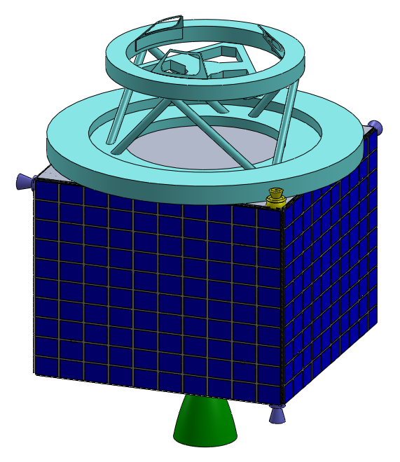

Figure 1 - HRV concept, view A, exterior shown

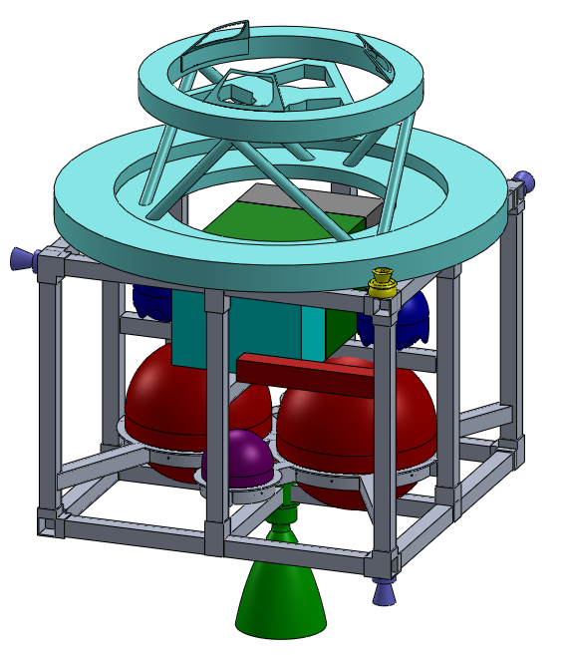

Figure 2 - HRV concept, view A, interior shown

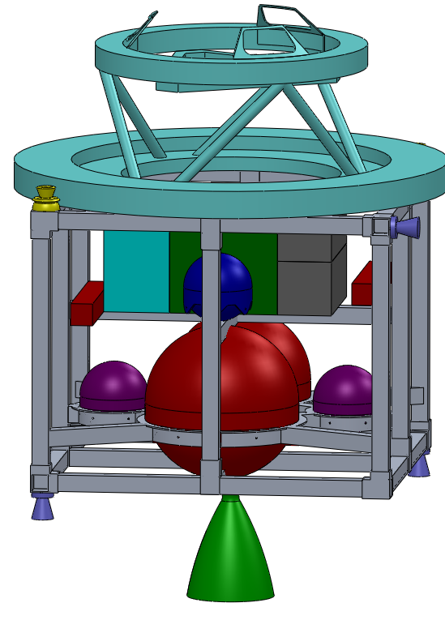

Figure 3 - HRV concept, view B, interior shown

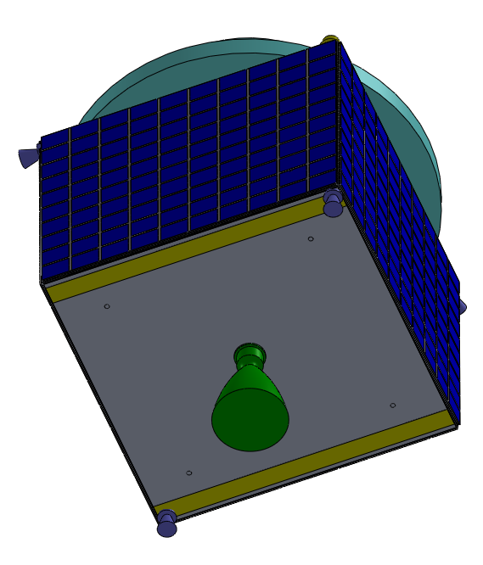

Figure 4 - HRV concept, view C, exterior shown

The total estimated (dry and fueled) mass breakdowns of the spacecraft are shown in below:

Table 1 - Estimated dry mass of HRV

|  |  |
| --- | --- |
| **Item** | **Mass (kg)** |
| XXX |  |
|  |  |
|  |  |
|  |  |

Table 2 - Estimated fueled mass of HRV

|  |  |
| --- | --- |
| **Item** | **Mass (kg)** |
| Dry mass |  |
| XXX |  |
|  |  |
|  |  |

With an origin in the center of the cube of the HRV, the center of mass is located at XXX, as shown in Figure 5.

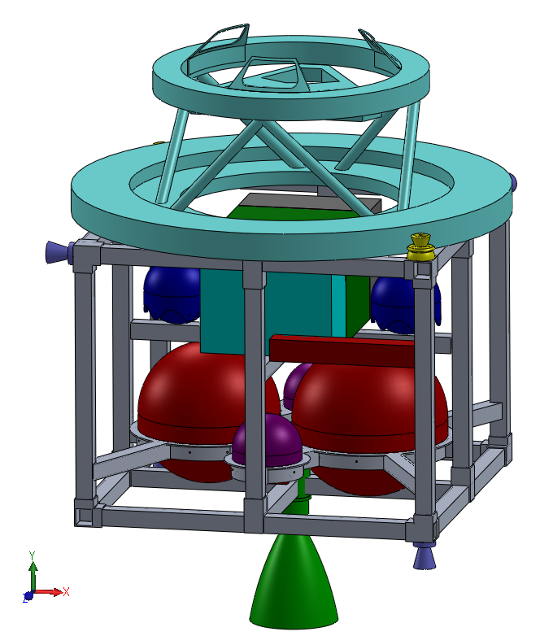

Figure 5 - Center of mass of HRV spacecraft

**Analyses and Test Plans**

As stated in the requirements, the spacecraft structure must have a higher stiffness than the minimum determined by the launch provider, and must meet all stress criteria within the FOS for quasi-static and vibrational loading. As of this report, the structural design has been completed to a PDR level, with basic analyses performed to prove the concept of the design strength, but without detailed or optimized analyses that would come in the next stage of the project.

*Natural Frequency of Structure*

The minimum natural frequency of the HRV structure is defined by the launch vehicle provider. With the Delta II 7320-10 as the selected launch vehicle, the minimum allowable natural frequency is 35 Hz in the thrust direction and 20 Hz in the lateral directions [1].

The structural design of the HRV uses aluminum extrusions with a wall thickness of .25” and an outer cube dimension of 3”, which results in a high stiffness. The first mode in the lateral direction is 148 Hz, while the first mode in the thrust direction is 142 Hz. The calculation process is shown below in Figure 1. The structure is assumed to act as a cantilever beam in bending, with an equivalent point mass at the center of mass of the spacecraft.

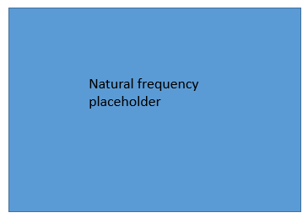

Figure 6 - Natural frequency calculations for HRV

*Quasi-Static Loads*

The maximum quasi-static loads are defined by [1] as 7.3 g in the axial direction and 3.0 g in the lateral direction. For the HRV spacecraft structure, quasi-static loads result in stress from axial force, bending stress, and buckling force loads (as well as negligible shear stress). See Figure 7 below.

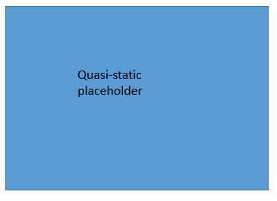

Figure 7 - Quasi-static stress analysis

*Vibration and Shock Loads*

Sinusoidal loads, random vibration loads, acoustic loads, and shock loads are beyond the scope of this PDR report. Sinusoidal loads for the Delta II at the HRV mass are lower than the quasi-static loads, and will therefore meet applicable margins of safety when performed after quasi-static load analyses. The shock response, random vibration power spectral density, and acoustic spectrum will depend on a more optimized design and analysis at a future point.

*Test Plans*

Qualification testing will be performed on a shaker table per the required loads, as defined in section 3 of this report, and as defined by future specifications from the launch provider and the HRV team. Qualification testing will be performed at an amplification factor of 1.4 for sinusoidal loads, XXX for XXX loads, and at a TBD factor for XXX loads.

**Solar Array Boom Deflection**

During this reboost mission, one of the mission objectives is to ensure that the maximum deflection of the solar panel arrays stays under 50 cm. This deflecting force occurs from the acceleration and mass of the panels while the reboost spacecraft is attached to HST, and at maximum thrust of 4000 N.

The current solar panels on the HST are the third iteration, and were installed during servicing mission 3B on STS-109 in 2002. The first two versions were very flexible, and could be rolled into the structural arm. A recorded video of an earlier reboost mission shows these panels undergoing an aggressive deformation. The current panel arrays are much more rigid, and are also about 30% smaller. See Figure 8 - Figure 10 below.

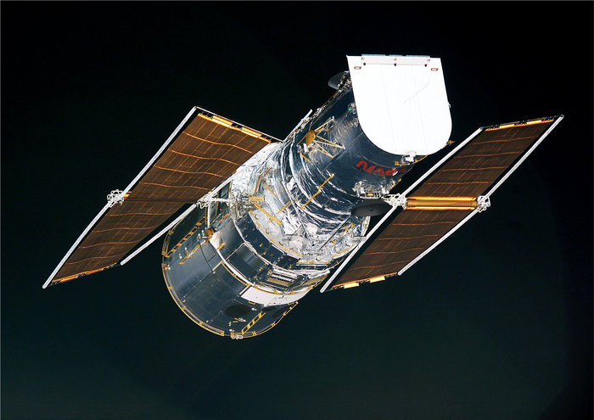

Figure 8 - Second iteration of solar panels, which were flexible (http://www.esa.int/spaceinimages/Images/2010/12/Hubble_with_its_second_set_of_ESA-designed_solar_blankets)

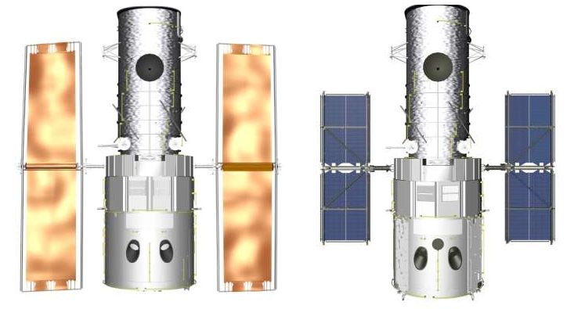

Figure 9 - Previous solar panel array (left) vs current solar panel array (right). http://asd.gsfc.nasa.gov/archive/sm3b/mission-critical/objectives-part2.html

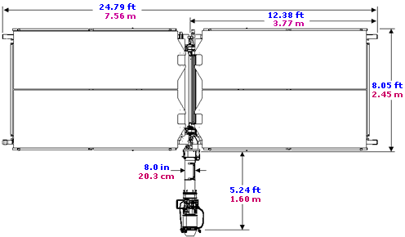

Figure 10 - Current solar panel array dimensions. http://asd.gsfc.nasa.gov/archive/hubble/art/shuttle_missions/sm3b/solpanel_measure.gif

Information taken from [2], [3], and Figure 10 was used to determine the design and material properties of the solar panel arrays. The deflection analysis was done with the following assumptions and descriptions:

* Both solar panel arrays are symmetric, so only one analysis is needed.
* The solar panels will be oriented so that they are parallel to the axis of the Hubble (which is the orientation shown in Figure 9). In this orientation, the long edge of the panels is in line with the thrusting force, so the induced bending moment is much lower than if they were rotated 90°.
* The arm which holds the solar panels is actually a complicated drive mechanism. It is modeled in this analysis as an aluminum shaft with a diameter of 4 cm, neglecting the surrounding mechanism.
* The Hubble is a rigid structure in comparison, and calculated deflection begins at the base of the drive mechanism.
* The array is modeled as a composite beam, as shown below in Figure 11 and Figure 12:
  + The drive mechanism shaft is beam AB, the middle double-extrusion section is beam BC, and the extrusion from the midspan to the tip of the array is beam CD.
  + Beam AB is a round aluminum shaft:
    - E = 68.5 GPa
  + Beam BC is a pair of extrusions made of Al-Li Alloy X2096-T8A3:
    - E = 75.15 GPa
  + Beam CD is modeled as a rigid structure, as it is in line with the thrust force and should not experience bending. Axial deflection is not considered to be significant.
  + The maximum deflection is at point D (which is equivalent to the deflection at the bottom right corner in Figure 11.)
  + It is assumed the solar panels themselves do not contribute to the stiffness of the structure, and that the area moment of inertia of beam BC is not increased due to a shear tie with the beam that runs parallel to CD from point B. Both of these are overly-conservative assumptions.
  + The transverse distributed loads found as follows:
    - * For the acceleration, the mass used is only for the Hubble. While the reboost spacecraft also has mass, its launch mass is <10% of the Hubble’s, and it will have used most of its fuel by the end of the boost, so its mass will be <5% of the Hubble’s. Neglecting the mass of the reboost spacecraft gives a slightly higher (and conservative) acceleration value.
      * For beam AB, the mass is of the drive mechanism.
      * For beam BC, the mass is of the structural beams and solar panels.
  + Using superposition, the deflection of point D is due to the summation of the components listed in Figure 12. A spreadsheet calculator was made and used to perform this calculation at different thrust levels, and is shown in Figure 13.

*Results/discussion:*

With a maximum thrust of the chosen rocket engine of 4000 N, the maximum mechanical deflection on the boom structure is calculated at **7.19 cm**. This is much lower than the allowable deflection of 50 cm, giving a factor of safety of 6.95.

It is preferable to have a high factor of safety in this situation, as there may be additional components to movement of the solar array other than structural deflection:

* The gearing in the drive mechanism at AB may have some play, allowing for a small amount of slippage under an abnormal load.
* There is a titanium flexure at point B, which is designed to provide stress relief during rapid heating (thermal induced stresses). The stiffness of this flexure in the described bending situation is not clear.

With the assumption that the main threat to the health of the solar panels is from mechanical deformation and not slippage or a localized flexible point, the maximum allowable thrust is calculated to be 27814 N, at which point the deflection would be 50 cm.

Table 3 - Solar Array Boom Deflection Summary

|  |  |
| --- | --- |
| Design thrust | 4000 N |
| Design deflection | 7.19 cm |
| Factor of safety | 6.95 |
| Maximum thrust (δ=50cm) | 27814 N |

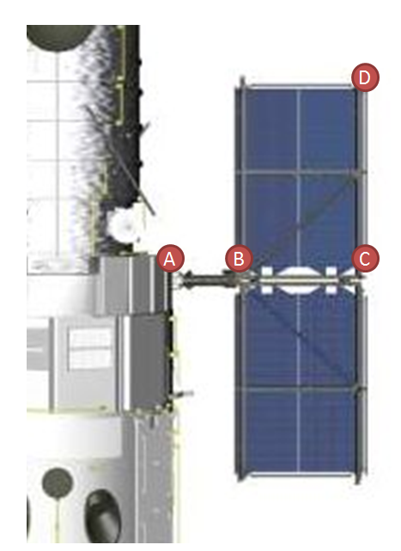

Figure 11 - Picture of Hubble solar array with labels corresponding to diagram

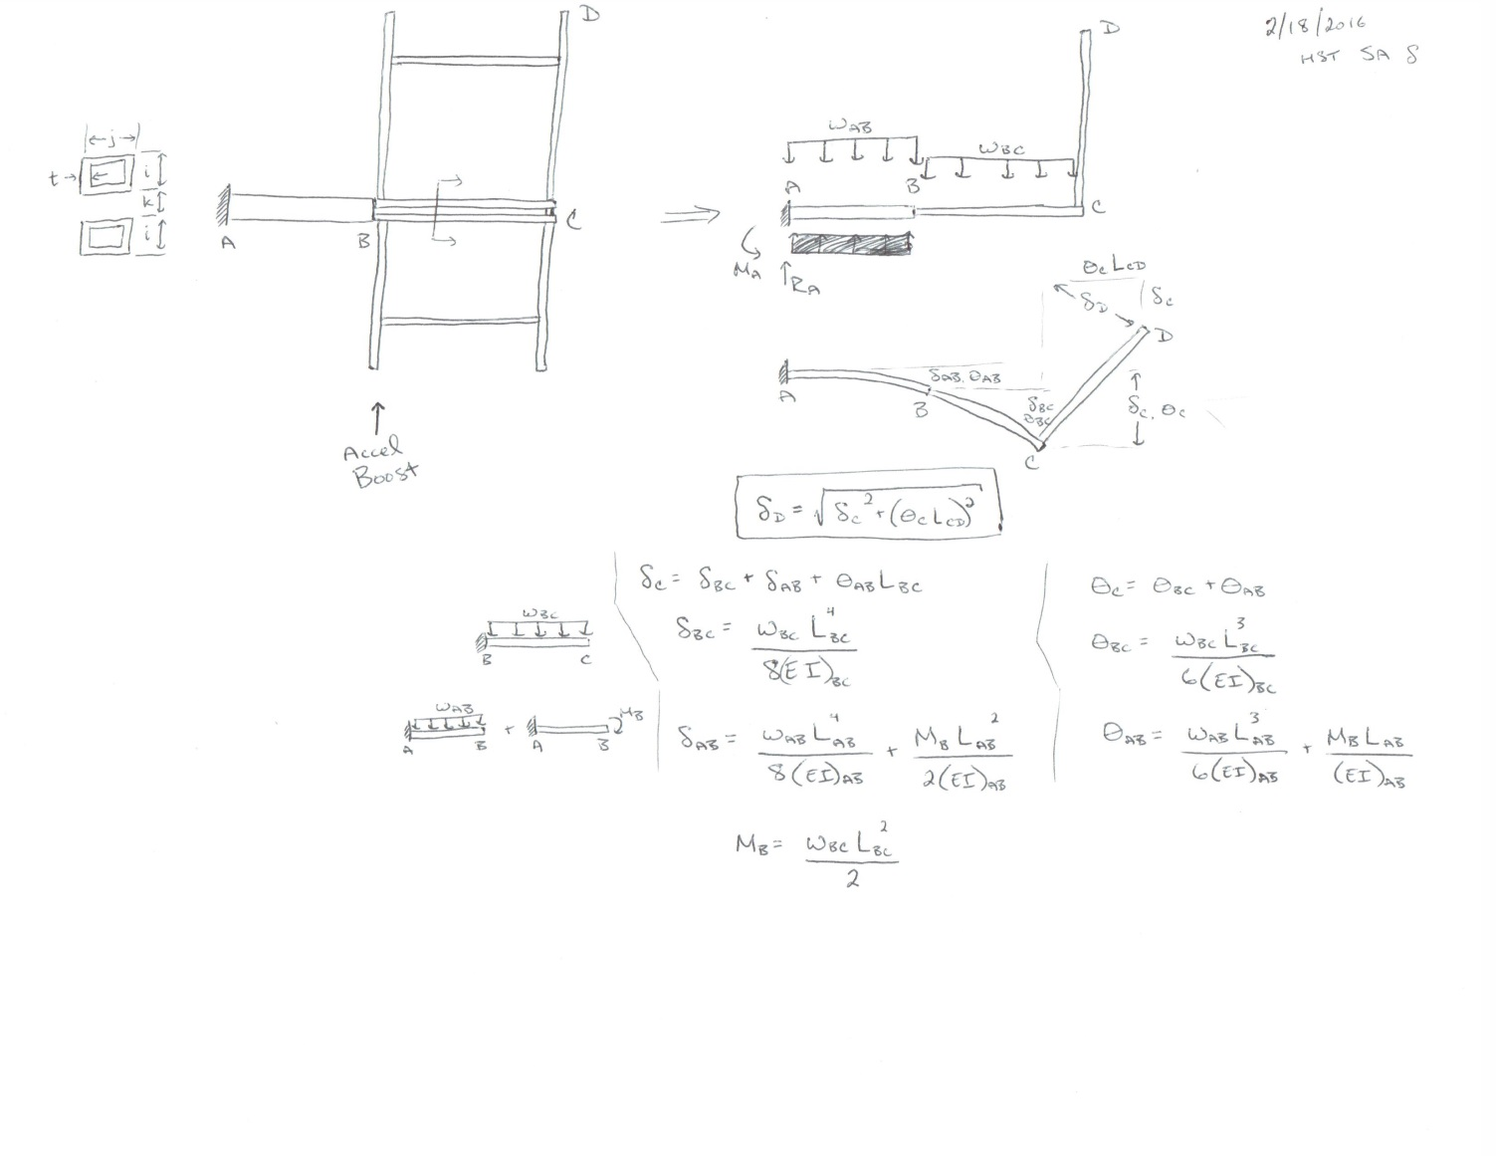

Figure 12 - Diagrams and equations used for solar array deflection calculation (order of calculations is from bottom to top)

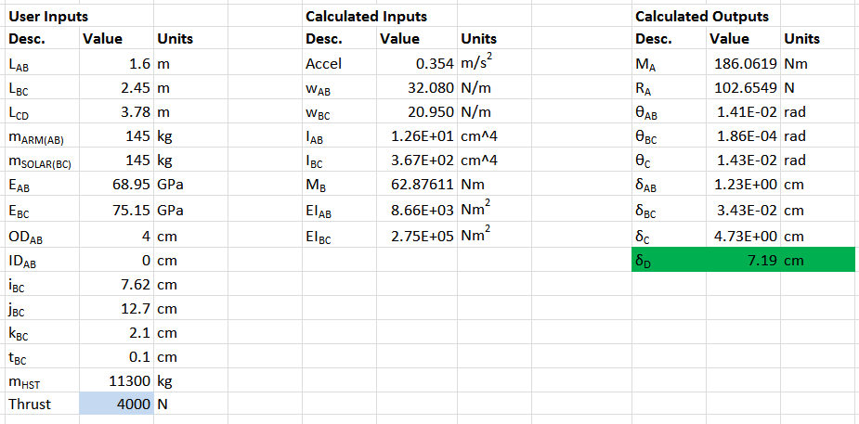

Figure 13 - Spreadsheet used to calculate solar array deflection

**References**

1. Delta II Payload Planners Guide, 2007
2. JSC29029: Cargo Systems Manual (CSM): Hubble Space Telescope. February 13, 2002
3. NASA/TP—1999—209203: Evaluation of Engineering Properties of Al-Li Alloy X2096-T8A3 Extrusion Products. August 1999